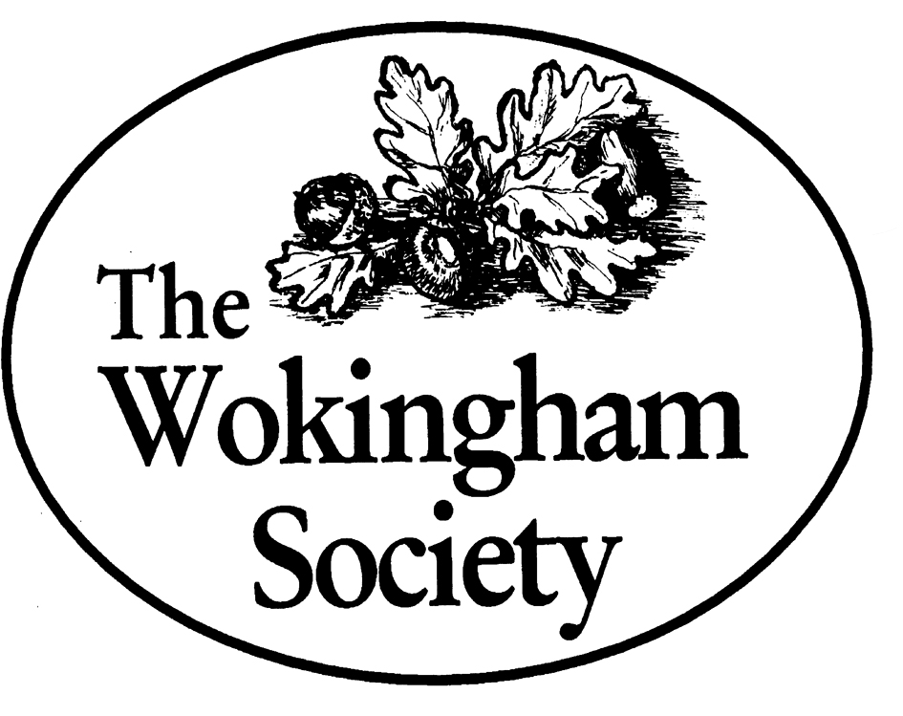
OPEN MEETING
7.45 PM FOR 8 PM ON WEDNESDAY 19 JUNE 2019 IN WOKINGHAM TOWN HALL

CARING FOR THE ENVIRONMENT: FRIENDS OF THE EMM BROOK AND THE ST PAUL’S TREE SUCCESSION PROJECT An illustrated talk by the two organisations
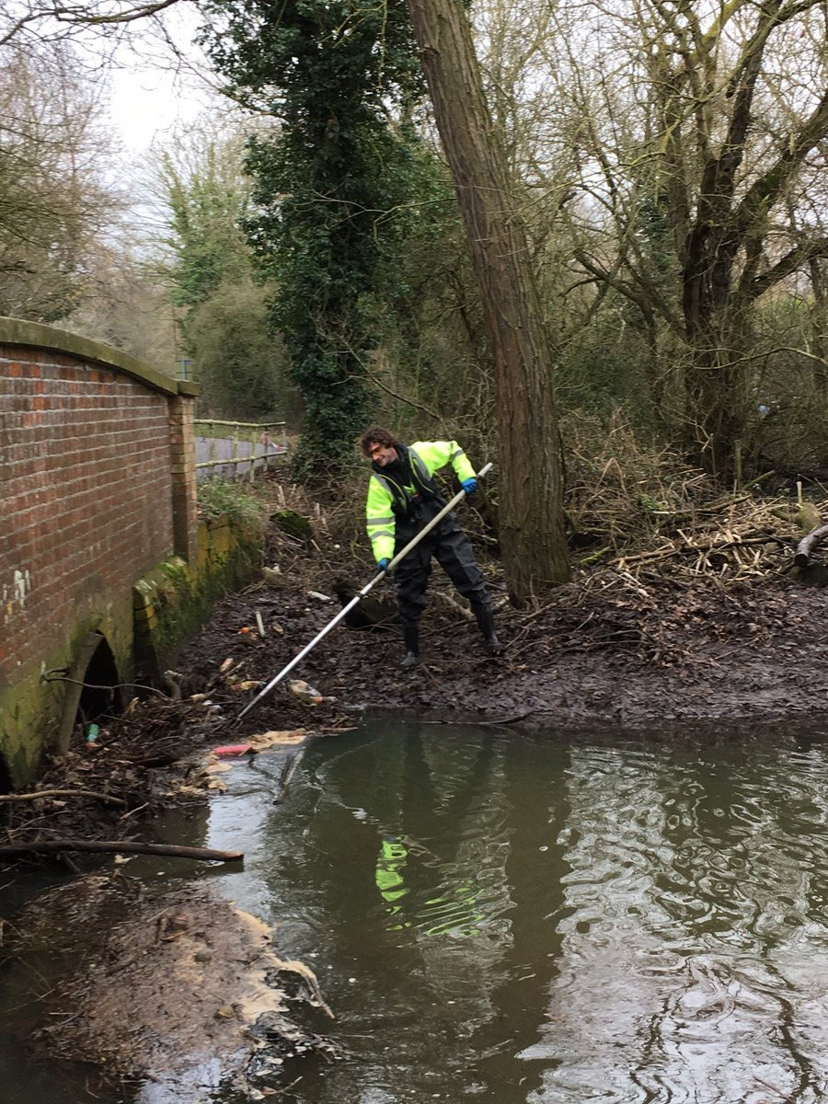
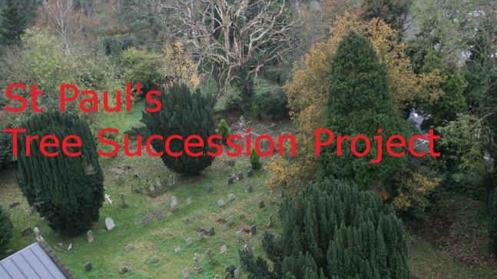

Stephanie MacKay and Eddie Napper of the Friends of the Emm Brook and Andy Clark of the St Paul’s Church Tree Succession Project will talk about, and illustrate, the work of their respective organisations. Both enterprises share a common mission of conservation and both have in the past been aided by grants from the Wokingham Society.
FREE ENTRY LIGHT REFRESHMENTS WILL BE SERVED AFTER THE MEETING

For more information contact: Peter Must, Wokingham Society Chairman
Telephone: 0118 9781671 email: chairman@wokinghamsociety.org.uk

